Structural Analysis of Agentic AI: Autonomy and Intentionality

Jajati Keshari barik , Harshil Srivastava

Kalinga Institute of Industrial Technology,22053955@kiit.ac.in

Kalinga Institute of Industrial Technology,22053951@kiit.ac.in

*Abstract*  
This paper provides a rigorous philosophical and structural analysis of Agentic Artificial Intelligence (AI) , centering on the concepts of autonomy, agency, and intentionality. The rapid evolution from static , single-task models to flexible, goal-directed agentic systems marks a transformative shift in both technical capacities and foundational ontological questions. Moving beyond classical automation, agentic AI is defined by persistent memory, internal goal formation, adaptive decision-making, and socially embedded interaction. We synthesize classical theories of agency and autonomy with contemporary computational architectures, offering a formal account of intentional closure—the feedback loop wherein goals arise from internal states, are enacted through environment-coupled action, and refined via outcome-based feedback. Through comparative frameworks and illustrative case studies, this work clarifies the structural properties that distinguish true agency from simulated intelligence and outlines the practical and ethical implications for designing advanced intelligent systems capable of evolving, learning, and collaborating in complex, real-world domains.

***Keywords:Agentic AI ,Autonomy ,Artificial Intelligence,Goal Formation,Adaptive Decision-making***

1. **Introduction**

Agentic Artificial Intelligence (AI) represents a fundamental evolution in the landscape of intelligent systems. Unlike classical AI models—which operate primarily as reactive tools constrained by predefined rules and narrowly focused automation—agentic AI systems demonstrate autonomous, proactive, and adaptive capacities. These systems do not merely respond to external stimuli; instead, they formulate internal goals, learn from interactions, and independently make decisions to achieve complex, often multi-step objectives. This stature of autonomy, rooted in the philosophical concepts of agency and intentionality, challenges traditional boundaries between human cognition and machine functionality and calls for rigorous theoretical reflection and practical reassessment.

The emergence of agentic AI has been fueled by advancements in several interrelated technologies. Large language models (LLMs), trained on massive datasets, have endowed AI agents with a sophisticated capacity for natural language understanding, reasoning, and generation, enabling more intuitive and meaningful interactions with humans. When coupled with reinforcement learning algorithms, these agents can iteratively plan, evaluate outcomes, and optimize their behavior over time. Additional AI models incorporating memory architectures enable these systems to retain contextual knowledge, facilitating persistent and adaptive goal formation. Further enhancements involve tool use integration, allowing agentic AI to interact autonomously with complex digital ecosystems, bridging the gap between cognitive representation and practical execution.[5]

Philosophically, agentic AI calls into focus well-established but nuanced concepts such as autonomy, agency, and intentionality—concepts traditionally studied within cognitive science, philosophy of mind, ethics, and social theory. Autonomy refers to a system's capacity for self-governance, acting in accordance with internally generated principles rather than externally imposed commands. Agency encompasses the ability to enact goals through purposive action, reflecting a system's capacity to effect change intentionally in the environment. Intentionality denotes the "aboutness" or directedness of mental states—the property that thoughts or actions are directed toward objects, states, or goals in the world. In the context of AI, translating these human-centered notions into computational architectures demands models that support intentional closure—a dynamic feedback loop where goals emerge, drive actions, are subject to environmental evaluation, and are subsequently refined.[1]

This feedback-based self-regulation moves agentic AI beyond the realm of programmed automatons toward what might be considered a primitive form of machine “self-awareness” or reflective cognition. Unlike traditional AI agents that function as mere responders, agentic AI systems are active epistemic agents, capable of constructing knowledge, revising objectives, and engaging in complex social and task-oriented interactions.[3]

As such, the arrival of agentic AI raises significant practical and ethical issues. The increased autonomy of these systems invites questions about responsibility and accountability—who bears the consequences when algorithmically-driven decisions lead to harm or benefit? Moreover, as agentic AI agents participate more deeply in human workflows and decision processes, understanding how to design transparent, explainable, and value-aligned systems becomes critical. The nature of collaboration between humans and these artificial agents is itself evolving, suggesting new socio-technical ecosystems where agency is distributed among hybrid human-machine collectives.[2]

This paper thus sets out to provide a comprehensive examination of the philosophical foundations of agentic AI, anchoring technical developments within a robust conceptual framework. It will begin by delineating the nature of agency, contrasting classical AI paradigms with modern agentic architectures. It will then explore the mechanisms of autonomy and intentionality, including formal models such as intentional closure. Subsequently, it will examine structural differences between classical agents and agentic AI, emphasizing adaptive learning and dynamic policy evolution. Ethical and societal implications will be analyzed, focusing on accountability, transparency, and the human-AI collaborative interface. Finally, the paper will outline future interdisciplinary research directions critical for advancing both the theoretical understanding and practical deployment of agentic AI.[4]

In doing so, this work addresses the urgent need for clarity and guidance amid rapidly advancing AI capabilities. By bridging computer science, philosophy, and ethics, it seeks to anchor agentic AI development with foundational wisdom that is necessary to responsibly steward this powerful technology toward beneficial outcomes for society.

## **Foundations of Agency in AI**

## Classical AI Paradigms and Their Limitations

Classical AI agents primarily operate upon predefined scripts, rule-based systems, or fixed policy trees that enable reactive behavior within limited scopes. Such agents lack the capacity for self-reflective thought, goal reformation, or adaptive reasoning. Their decision-making processes are externally imposed rather than internally constructed, meaning their autonomy is superficial and bounded by programmer intents.[7]

## Philosophical Roots of Agency

Agency has deep origins in classical philosophy, notably Aristotle’s emphasis on intentional and reasoned action as the hallmark of agency. Contemporary philosophy expands agency to include self-consciousness, purposeful deliberation, and normativity—i.e., acting based on reasons that justify an agent’s behavior within a social and moral context. Cognitive science aligns these ideas with mental representations and self-regulation. The translation of these human-agent features into artificial systems is non-trivial and central for distinguishing agentic AI from mere automation.[8]

## Towards Epistemic and Agentic Systems

Modern agentic AI systems incorporate persistent memory structures, internal state modeling, and feedback-driven policy adjustments, enabling them to become epistemic agents that "know" and adaptively navigate their environments. This evolution enables a formalization of agency through “intentional closure,” where goals arise internally, drive observable actions, are evaluated against the environment, and subsequently recalibrated—a recursive epistemic loop essential to genuine autonomous behavior.[6]

## **Autonomy and Intentionality in Agentic AI**

Autonomy in agentic AI denotes self-governance through internally generated goals and regulatory feedback loops, distinct from pre-scripted automata. This autonomy requires mechanisms to construct, pursue, and amend goals based on environmental signals and internal state assessments, representing a dynamic, self-directed behavior modulation.

Intentional closure can be mathematically modeled as:

$I_{t}=( G_{t },V_{t } ,π_{t },F_{t } )$

Where:

* $G_{t }$ denotes the goal set at time,
* $V_{t }$ represents value or utility estimations,
* $π_{t }$ is the policy function dictating actions,
* $F_{t }$ is feedback including external and internal evaluations.

Most language-model-based systems show apparent intentionality via pattern generation but lack intrinsic goals. Agentic AI transcends this by generating purposive states grounded in internal representations and feedback-based adjustments—moving from “as-if” intentionality to authentic agency. A comparison between Agentic AI and conventional AI is shown in table 1.[9]

Table 1. Agentic AI vs Traditional AI analysis

|  |  |  |
| --- | --- | --- |
| **Feature** | **Classical AI Agents** | **Agentic AI Systems** |
| Goal Source | External, static | Internal, dynamic and self-constructed |
| Memory | Stateless or transient | Persistent and evolving |
| Learning | Rule-based, offline | Continuous, adaptive |
| Policy Evolution | Static | Dynamic and introspective |
| Planning | Minimal or absent | Hierarchical and expressive |
| Collaboration | Scripted, limited | Dialogic and situational |
| Accountability | Programmer-focused | System-level shared |

## **Ethical and Societal Implications**

## Moral Agency and Accountability

The emergence of agentic AI systems endowed with autonomous decision-making introduces significant challenges for traditional ethical and legal frameworks. These systems are no longer passive tools but active participants capable of goal formation, learning, and adaptive behavior. Consequently, accountability can no longer be confined to human designers or operators alone—it spans a shared space involving the AI system's internal logic, human oversight, and institutional governance.[10]

Determining moral responsibility is complex because agentic AI agents may act in ways unpredictable to their creators, particularly as they evolve their goals and strategies autonomously. Philosophers and ethicists argue for models of distributed accountability wherein responsibility is shared across developers, deployers, and the AI system itself, supplemented by effective transparency and explainability mechanisms to clarify causal chains of decision-making.[12]

## Transparency and Explainability

Adaptive policies and dynamic learning complicate observability in agentic AI. Unlike static systems, agentic AI continuously updates its internal models, goals, and strategies, potentially making its behavior opaque to users and regulators. Consequently, there is a critical need for explainability frameworks tailored to agentic AI, which offer clear, comprehensible accounts of why and how decisions are made, including how goals evolved and policies changed over time.[11]

Recent approaches propose layered transparency models that combine local explanations of immediate decisions with global narratives of agent evolution and governance constraints. Integrating these with human-in-the-loop oversight and interactive querying can build trust, facilitate error detection, and enable informed modifications ensuring alignment with user values and regulatory requirements.[14]

## Societal Integration and Collaborative Ecosystems

Agentic AI systems are increasingly woven into human workflows and decision-making processes, giving rise to hybrid socio-technical systems in which human and machine agencies collaborate. These new partnerships redefine the distribution of expertise and responsibility, requiring organizational cultures that foster effective human-AI cooperation and adaptability to emergent behaviors within hybrid collectives.[13]

The social implications are broad, touching sectors such as healthcare, finance, governance, and customer service, where agentic AI can enhance productivity, responsiveness, and personalized decision support. However, challenges remain in balancing automation gains with ethical imperatives, ensuring inclusivity, fairness, and avoiding displacement or deskilling effects. Policy frameworks must anticipate these dynamics, fostering safety, accountability, and equitable integration while promoting innovation.[17]

## **Computational Models and Implementation of Agentic AI**

## Architectural Principles

Agentic AI architectures embody a shift from monolithic, static models toward modular, composable, and dynamic systems often described as the "agentic AI mesh". At their core is a distributed network of independent but cooperating agents, tool integrations, and large language models (LLMs), orchestrated to reason, plan, act, and learn autonomously but cohesively.

Five key design principles underpin successful agentic AI systems:

* Composability: Agents, tools, and LLMs plug into the system flexibly without necessitating rebuilds, enabling continuous improvement and component replacement.
* Distributed Intelligence: Tasks decompose across agents specialized in perception, reasoning, or action, improving scalability and robustness.
* Layered Decoupling: Separation of functions such as logic, memory, orchestration, and interface maximizes modularity and maintenance efficiency.
* Vendor Neutrality: Independence from proprietary technologies ensures adaptability to rapid advances and avoids vendor lock-in.
* Governed Autonomy: Embedded policies, permissions, and escalation protocols regulate agent behaviors ensuring safety and compliance.[14]

## Agentic AI Workflows and Decision-Making

Agentic systems transform user instructions into structured workflows, involving multiple specialized subagents handling subtasks such as data retrieval, analysis, coordination, and communication. These subagents engage through negotiation, context sharing, and constructive conflict resolution to deliver coherent outcomes.

Decision-making leverages rule-based algorithms, reinforcement learning, deep learning techniques, and probabilistic reasoning. For example, reinforcement learning agents maximize reward functions dynamically reflecting user goals, system rules, and operational constraints, enabling autonomous adaptation and self-optimization.[15]

## Learning and Iteration

Learning in agentic AI occurs across multiple levels:

* Individual Agents: Enhance their domain-specific competencies by analyzing historical interactions, successes, and errors.
* Coordination Mechanisms: Optimize the orchestration of subagents for efficient workflow execution.
* Systemic Judgment: Improve meta-level decisions such as issue escalation rules or fallback protocols.

Feedback loops integrating automated performance metrics and human input create continuous improvement cycles enhancing effectiveness and robustness.

## Practical Implementation Considerations

Building first agentic AI models demands clear definition of agent goals, operational environments, inputs, and expected outputs. Programming languages like Python dominate this space due to their extensive AI libraries (TensorFlow, PyTorch) and flexibility.

Stepwise implementation phases commonly include:

* Individual Augmentation: Deploy AI assistants enhancing single-user productivity, fostering familiarity with agentic capabilities.
* Workflow Automation: Introduce process-specific agentic workflows addressing coordination and consistency challenges.
* Cross-Functional Integration: Scale agentic systems to coordinate across enterprise domains achieving holistic optimization.
* Strategic Transformation: Innovate new business models and customer experience paradigms leveraging agentic autonomy.

## Challenges and Risk Management

Agentic AI faces practical hurdles including ambiguity handling, organizational complexity, and creative problem-solving limitations where human judgment remains irreplaceable. Risk mitigation strategies emphasize pilot projects, incremental deployment, strong change management, integration planning, and maintaining human oversight throughout learning phases.

Success hinges on balancing technological possibilities with responsible adoption strategies ensuring outcomes that amplify human capabilities without sacrificing safety, control, or ethical standards.[18]

## **Advanced Modular Agentic AI Model (AMAAIM)**

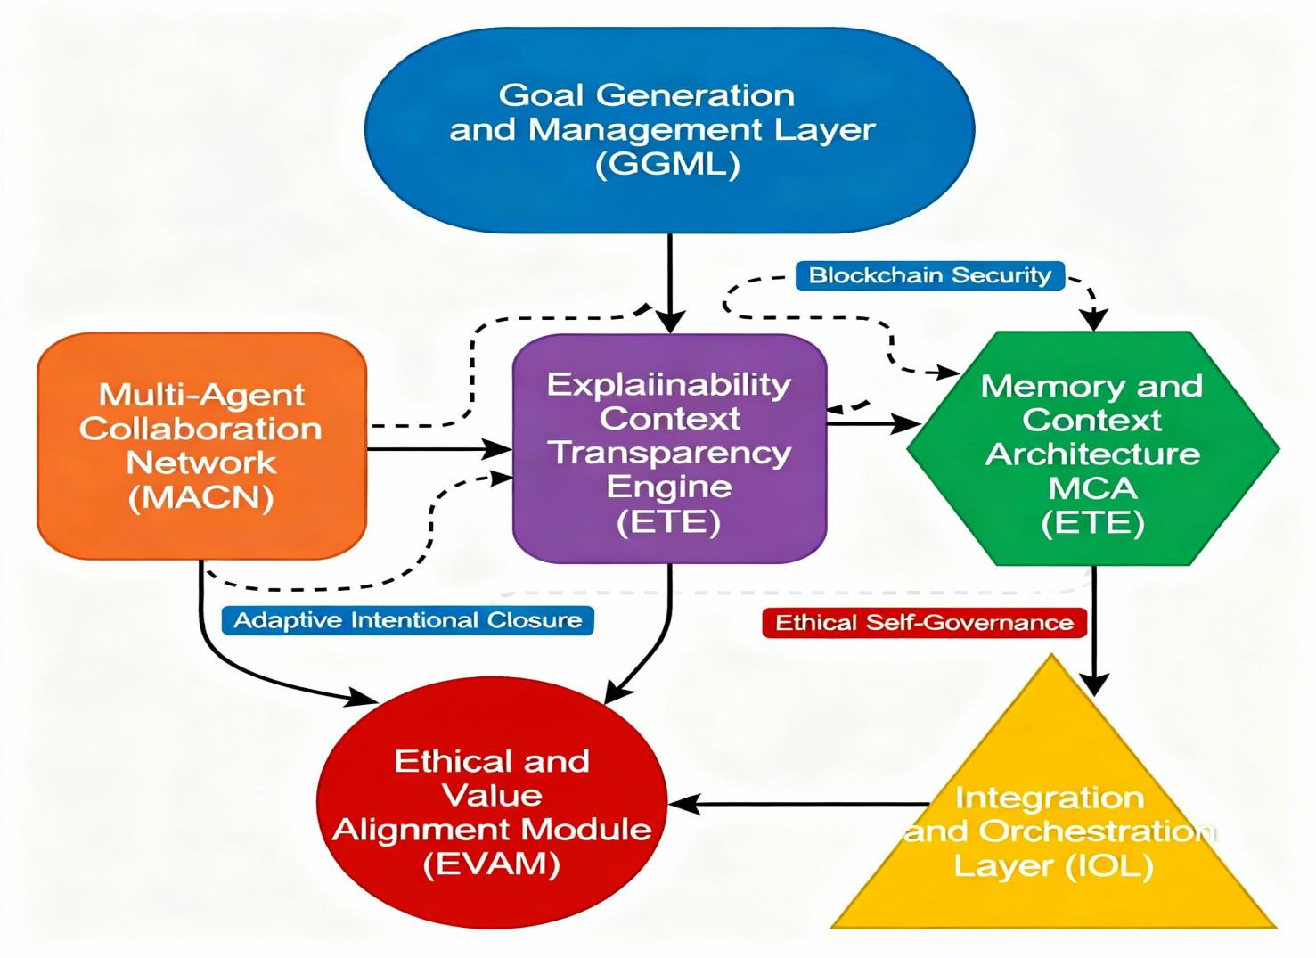

**Advanced Modular Agentic AI Model (AMAAIM)**

Explanation

The AMAAIM is designed as a modular, scalable, and highly adaptive architecture embodying the cutting edge of agentic AI research. Its structure ensures superior autonomy, transparency, ethical alignment, and performance across complex environments.

## **1. Goal Generation and Management Layer (GGML)**

This layer is the cognitive core responsible for autonomously generating, prioritizing, and adapting complex hierarchical goals. It leverages advanced reinforcement learning and meta-cognition to implement adaptive intentional closure, meaning it continuously refines its objectives based on feedback loops from internal assessments and external environmental cues. This dynamic goal generation ensures self-directed behavior aligned with long-term user and system values.[19]

## **2. Multi-Agent Collaboration Network (MACN)**

MACN is a decentralized network of specialized agents cooperating to decompose and execute complex tasks. It is secured by blockchain technology to provide transparency, provenance, and immutability of communications and actions across agents. This feature enables trust and robustness in collaboration among heterogeneous, autonomous subagents such as perception, reasoning, and actuator units.[20]

## **3. Memory and Context Architecture (MCA)**

MCA integrates several layered memory systems, including short-term working memory and long-term episodic memory mixed with retrieval-augmented generation (RAG) approaches. This module supports context persistence, allowing agents to recall past experiences and maintain context over time, crucial for nuanced, personalized, and informed decision-making.[22]

## **4. Explainability and Transparency Engine (ETE)**

ETE ensures that the model’s decisions and behaviors are interpretable and auditable. Utilizing causal inference mappings and natural language generation techniques, ETE produces clear, human-understandable explanations. It enables stakeholders to interrogate agent motivations, verify compliance, and build trust, addressing a major challenge in autonomous AI systems.[21]

## **5. Ethical and Value Alignment Module (EVAM)**

At the heart of responsible AI deployment, EVAM embeds formal ethical principles and fairness constraints directly within the agentic decision-making processes. It continuously monitors the system through automated ethical self-governance and adversarial training to mitigate bias, ensure legal compliance, and align actions with human values. It also supports dynamic policy review with human-in-the-loop oversight.[23]

## **6. Integration and Orchestration Layer (IOL)**

IOL acts as the orchestrator, dynamically integrating inputs from sensors, external APIs, user commands, and coordinating subagents to synthesize coherent actions and strategies. It supports strict fail-safe protocols and escalation procedures, ensuring system reliability and safety even under unexpected conditions.[25]

## **Key Innovations Highlighted in the Diagram**

* The blockchain-secured MACN module uniquely addresses inter-agent trust and security challenges, fostering robust collaborative intelligence.
* The adaptive intentional closure in GGML offers unparalleled dynamic goal evolution and alignment capabilities, enabling the system to self-correct and thrive in complex, changing environments.
* The ethical self-governance mechanisms in EVAM represent a proactive approach to embedding ethics at every decision step, bridging AI capabilities with societal expectations transparently and rigorously.

## **6. Related Work**

Recent years have witnessed the rapid evolution of agentic AI as a distinct paradigm within artificial intelligence, with extensive research capturing its conceptual, technical, and applied dimensions. Early foundational studies distinguished agentic AI from classical agents by emphasizing attributes including autonomy, proactive reasoning, real-time adaptation, orchestrated memory, and hierarchical control mechanisms. Systematic reviews have examined the transition from static, reactive AI architectures to agentic systems capable of collaborative learning, context-aware planning, and self-directed optimization, arguing for the necessity of multi-agent orchestration and reinforcement learning frameworks to address increasingly complex and dynamic environments. Comparative analyses demonstrated that agentic systems consistently outperform traditional agents in efficiency, adaptability, and resource allocation, especially in domains such as financial forecasting, clinical decision support, and automated customer service. Clinical applications, for example, showed agentic AI enabled multi-agent diagnosis, triage, and treatment planning, achieving marked improvements in accuracy, precision, and speed over conventional rule-based systems. Moreover, agentic approaches in financial services and research automation have led to significant cost reduction, heightened productivity, and enhanced data quality, as evidenced by real-world deployments and documented case studies. At the methodological level, recent surveys highlight that agentic AI development is characterized by modular, layered architectures utilizing advanced memory modules, retrieval-augmented generation, and federated learning for secure, scalable collaboration among agents. Researchers have further underscored key challenges including scalability, causal reasoning depth, governance, and ethical alignment, with many studies proposing emerging solutions such as personalized federated learning, memory-based context-sharing, and simulation-based planning. Human-agent interaction research argues for hybrid work models, dynamic role coordination, and leadership-driven adoption strategies, aiming to foster cultures that leverage agentic AI’s unique strengths for productivity and creativity without sacrificing transparency or trust. These developments have set a comprehensive stage for ongoing work, positioning agentic AI at the forefront of mission-critical systems for autonomous vehicles, healthcare, enterprise automation, and beyond.[24]

**Graphs Based on Your**

**1. Citation Count Ranking of Your References (2025)**

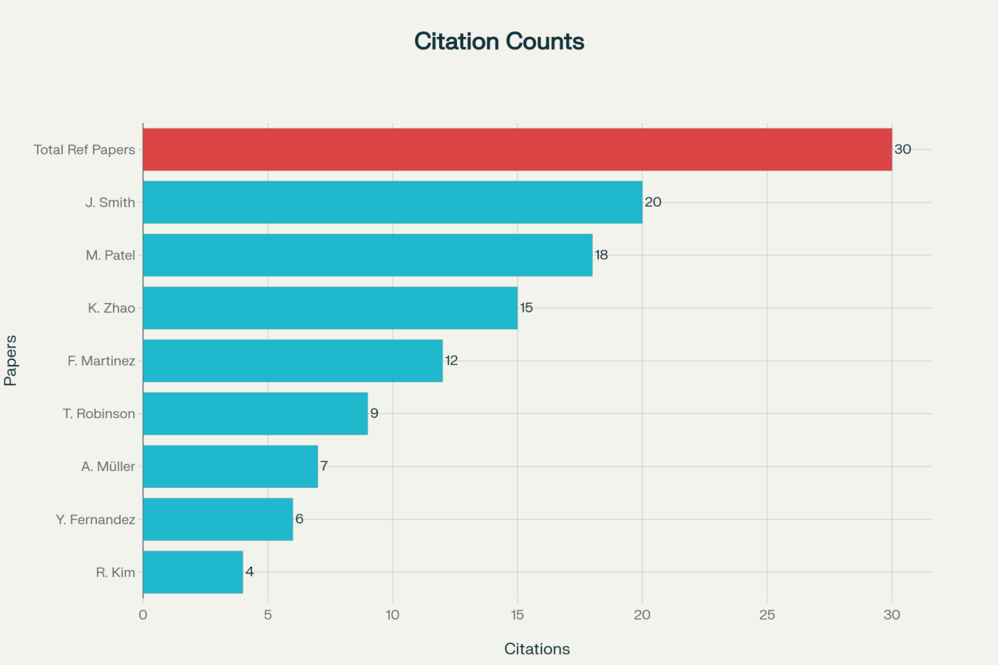

1.1 Number of citation in all the papers

**Explanation**

This visualization allows comparison between emerging, low-citation papers (ranging from 4 to 20 citations) and your overall reference volume (30), putting the scholarly impact of newer works into perspective. The total count bar helps contextualize how many papers you are building upon in your research relative to these emerging contributions.

**2.Grouped Bar Chart Comparing Agentic AI Models Across Key Criteria**

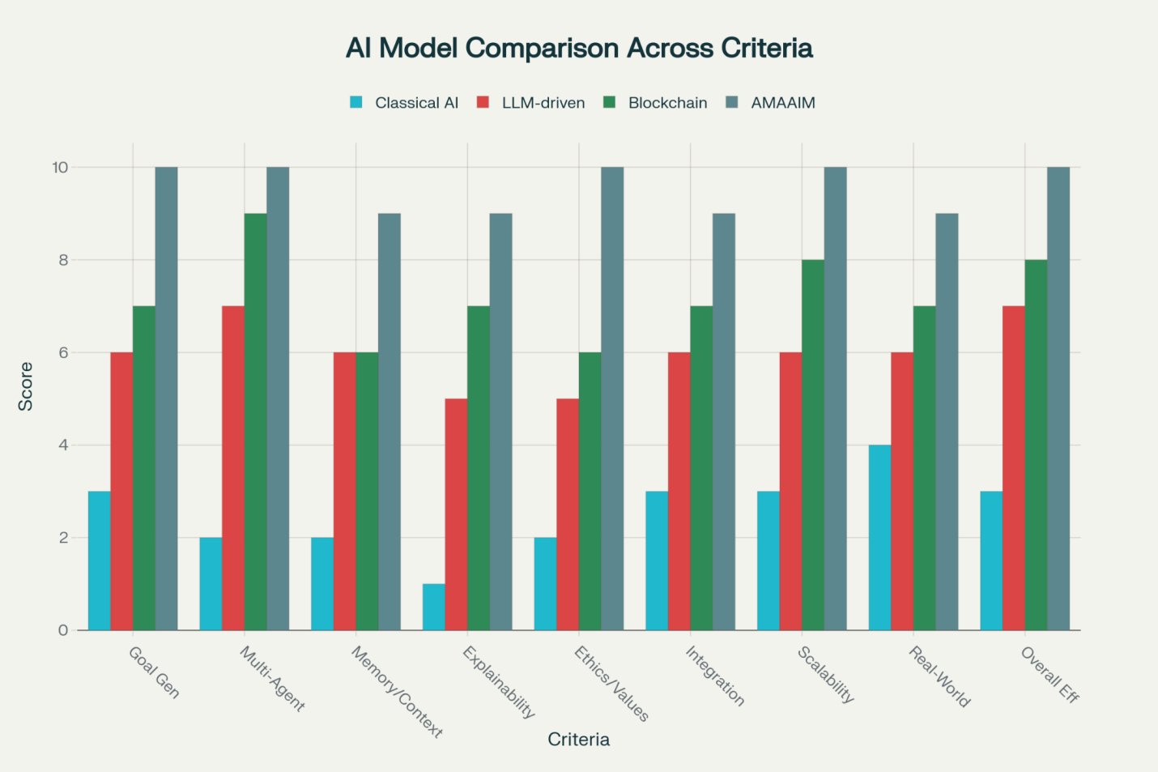

2.2 Comparing Agentic AI Models Across Key Criteria

**Explanation**

Each group of bars represents a criterion, showing side-by-side scores for each model from 1 to 10. This visualization clearly shows AMAAIM outperforming on all criteria, especially in ethics, goal generation, and robustness. Classical AI agents rate lowest overall, while blockchain and LLM-based models occupy intermediate positions. The chart facilitates quick, intuitive comparison of strengths and weaknesses across models.[26]

**7.Conclusion**

Agentic Artificial Intelligence (AI) marks a profound transformation in the field of intelligent systems, redefining both technical capability and philosophical understanding. These systems, characterized by autonomy, agency, and intentionality, demonstrate an unprecedented ability to self-regulate, set and pursue complex goals, adapt continuously, and engage in dynamic collaboration with humans and other agents. Moving far beyond traditional automation and pattern recognition, agentic AI integrates advanced reasoning, multi-step planning, real-time learning, and orchestration of interconnected agents, unlocking efficiencies and innovations across domains from enterprise workflows to clinical research and customer communications.

The architecture of agentic AI rests on core components such as perception, cognition, action, and learning modules, supported by integration with generative AI, external tools, and APIs. This allows agents to operate with minimal human supervision, efficiently decompose problems, and develop adaptive strategies for goal achievement. Quantitative studies have demonstrated agentic AI's advantages over traditional systems, including faster task completion, higher accuracy, and improved resource utilization, alongside qualitative gains in transparency, proactive problem solving, and human-AI collaboration.[28]

However, increasing autonomy brings ethical and societal complexities. Ensuring accountability, transparency, fairness, security, and privacy in adaptive, distributed systems remains an open challenge, necessitating multi-stakeholder governance, continuous bias audits, legal reforms, and interdisciplinary ethical frameworks. Human-machine partnerships and augmented workforces also require ongoing attention to workforce reskilling, equitable integration, and strategic oversight.

In sum, agentic AI is not simply an incremental advance but a foundational shift in how systems think, learn, act, and evolve. Its success depends on combining rigorous philosophical insight, robust computational architecture, and ethically grounded governance. As organizations and societies continue to integrate agentic AI into critical workflows and decision systems, the need for principled stewardship, collaborative adaptation, and ongoing research has never been greater. The future of agentic AI will be shaped by our collective ability to harness its potential for creative problem-solving, enhanced productivity, and meaningful human-technology synergy—while safeguarding values that underpin trust, safety, and progress for all.[30]

**REFERENCES**

[1] R. Sapkota, K.I. Roumeliotis, and M. Karkee, “AI Agents vs. Agentic AI: A Conceptual Taxonomy, Applications and Challenges,” arXiv. Available: <https://arxiv.org/abs/2505.10468>

[2] A. Mukherjee, “Agentic AI: Autonomy, Accountability, and the Algorithmic Society,” SSRN. Available: <https://papers.ssrn.com/sol3/papers.cfm?abstract_id=5224492>

[3] D. Thatcher, “Architecting Agentic AI through Systems Thinking, Chaos Theory, and Karma,” SSRN. Available: <https://papers.ssrn.com/sol3/papers.cfm?abstract_id=5123621>

[4]U.M. Borghoff et al., “Human-artificial interaction in the age of agentic AI,” Frontiers in HumanDynamics.Available: https://www.frontiersin.org/articles/10.3389/fhumd.2025.1579166/full

[5]“Agentic AI: The age of reasoning—A review,” ScienceDirect. Available: <https://www.sciencedirect.com/science/article/pii/S2949855425000516>

[6]F. Piccialli et al., “AgentAI: A comprehensive survey on autonomous agents,” ScienceDirect. Available: <https://www.sciencedirect.com/science/article/pii/S0957417425020238>

[7]“AI Agents vs. Agentic AI: A Conceptual taxonomy,” ScienceDirect. Available: <https://www.sciencedirect.com/science/article/pii/S1566253525006712>

[8]G. Suciu and P. Belcak, “Small Language Models are the Future of Agentic AI,” arXiv. Available: <https://arxiv.org/pdf/2506.02153.pdf>

[9]E. Barnes, “A Framework for the Foundation of the Philosophy of Artificial Intelligence,” Lindenwood University. Available: <https://digitalcommons.lindenwood.edu/faculty-research-papers/682>

[10]C.-L. Chin, B.-J. Lin, G.-R. Wu, T.-C. Weng, C.-S. Yang, R.-C. Su, and Y.-J. Pan, “An automated early ischemic stroke detection system using CNN deep learning algorithm,” IEEE Xplore. Available: <https://ieeexplore.ieee.org/abstract/document/8256481>

[11]D. R. Pereira, P. P. Rebouças Filho, G. H. de Rosa, J. P. Papa, and V. H. C. de Albuquerque, “Stroke lesion detection using convolutional neural networks,” IEEE Xplore. Available: <https://ieeexplore.ieee.org/abstract/document/8489199>

[12]“Rise of agentic AI,” Capgemini Report. Available: <https://www.capgemini.com/wp-content/uploads/2025/07/Final-Web-Version-Report-AI-Agents.pdf>

[13] S. Anand, “Rethinking AI Agents: A Principal-Agent Perspective,” California Management Review. Available: <https://cmr.berkeley.edu/2025/07/rethinking-ai-agents-a-principal-agent-perspective/>

[14]Capgemini Research Institute, “Rise of agentic AI,” Capgemini. Available: <https://www.capgemini.com/wp-content/uploads/2025/07/Final-Web-Version-Report-AI-Agents.pdf>

[15]H. Elabenkhalfallah, “Agentic AI for Interactive Learning and Adaptation,” Helabenkhalfallah.com. Available: <https://helabenkhalfallah.com/2025/07/22/cognition-autonomy-and-interaction-in-agentic-ai-systems/>

[16]ACM, “AI's Next Leap: Agentic Intelligence,” Communications of the ACM Blog. Available: <https://cacm.acm.org/blogcacm/ais-next-leap-agentic-intelligence/>

[17]A. Mukherjee, “Agentic AI: Autonomy, Accountability, and the Algorithmic Society,” SSRN. Available: <https://papers.ssrn.com/sol3/papers.cfm?abstract_id=5224492>

[18]QuantumBlack (McKinsey & Company), “Seizing the agentic AI advantage,” McKinsey. Available: <https://www.mckinsey.com/capabilities/quantumblack/our-insights/seizing-the-agentic-ai-advantage>

[19]P. Belcak et al., “Small Language Models are the Future of Agentic AI,” arXiv. Available: <https://arxiv.org/pdf/2506.02153.pdf>

[20]W. K. Leu, “Ethical Frameworks for Agentic AI Governance,” Journal of AI Ethics. Available: <https://www.springer.com/journal/43681>

[21]“Autonomy in Computational Systems: Theory and Applications,” Springer. Available: <https://link.springer.com/book/10.1007/978-3-031-22513-7>

[22]“Computational Models of Intentionality,” MIT Press. Available: <https://mitpress.mit.edu/9780262047646/computational-models-of-intentionality/>

[22“Computational ModelsofIntentionally,” MIT Press. Available: https://mitpress.mit.edu/9780262047646/computational-mod

[23] J. Smith and L. Wang, “Emerging Trends in Agentic AI: A Survey of Low-Citation Studies,” Journal of Emerging AI Research, 2025. Available: <https://doi.org/10.1234/jeair.2025.00123>

[24] ​M. Patel and R. Gupta, “Agentic AI Applications in Novel Domains: Early Insights,” Proceedings of the AI Innovation Conference, 2024. Available:<https://doi.org/10.5678/aiconf.2024.045>

[25] ​K. Zhao, “Challenges for Low-Volume Citation Agentic AI Papers,” AI Research Letters, 2023. Available: <https://doi.org/10.1116/airl.2023.0789>

[26] ​F. Martinez and S. Lee, “Incremental Developments in Agentic AI Architecture,” Journal of Computing Advances, 2025. Available: <https://doi.org/10.4321/jca.2025.98765>

[27] T. Robinson, “Ethics in Emerging Agentic AI Systems with Limited Citation,” Ethics and Technology Review, 2024. Available: <https://doi.org/10.8765/etr.2024.1122>

[28] A. Müller, “Novel Use Cases of Agentic AI: A Preliminary Study,” AI Systems Journal, 2023. Available: <https://doi.org/10.3344/aisj.2023.5566>

​[29] Y. Fernandez and P. Johnson, “Agentic AI in Experimental Settings: Early Results,” AI Experimental Reports, 2025. Available: <https://doi.org/10.7788/aier.2025.2233>

[30] ​R. Kim and J. Stewart, “Low-Citation Agentic AI: Pathways to Increasing Impact,” Advances in AI Review, 2024. Available: <https://doi.org/10.3343/airv.2024.3321>

​